**Information:**

Interview conducted with Interviewee 6 (male; works in IT)

38 minutes

Language spoken: English

Automatic transcription done with Zoom Audio transcription, and checked by a coder.

**Follow-up to the survey on the use of machine translation in health contexts**

**Researcher:** Thank you again for accepting to participate in this interview. As you already know, this is a follow-up interview to the questionnaire on the use of machine translation in healthcare in the Netherlands. You replied to this questionnaire earlier this year. Let me start by reminding you that this interview is being recorded. The data collected will be anonymized and analyzed together with other participants’ data. The recording itself will never be published or shared, and it will be deleted as soon as it is transcribed and anonymized. You are free to request a copy of the transcription. In the interview itself, we will invite you to go over potential scenarios regarding the use of technology - specifically, machine translation like Google translate or any other translation system on your phone or device - in healthcare contexts, like when you receive an invitation letter to get vaccinated or when you go to the doctor, huisarts.  The goal is to understand how machine translation can be used and what are the main challenges or opportunities when using it. We aim to create free training for users of machine translation like yourself in order to better support communities in these situations. The scenarios that we will show you are fictitious. They are potential scenarios or stories. The focus is on what you think a person would do if they were in this situation. Discuss anything that comes to mind or that you would like to share. We just ask you not to share confidential information about yourself.  If at any point, during the interview, you feel uncomfortable and you want to pause the interview, please just let us know. We can rephrase the question or stop the interview altogether. You can leave at any point during this interview. Any questions or concerns?

**Participant:** No.

**[STAGE 1 SLIDE 2]**

**Researcher:** I will start now by reading the first scenario that you can also see on the screen.“Two years ago, Manuel moved to the Netherlands from Italy. It was right amid the pandemic, and he moved to take up a position at a new company in Rotterdam. Manuel is a native speaker of Italian, and he also speaks English. He has taken two Dutch courses online, so he understands and speaks rudimentary Dutch. For example, he can ask for a drink or have short conversations with neighbors, but not enough to feel fully comfortable speaking Dutch fluently in all situations. In 2021, he received a letter from the RIVM inviting him to get vaccinated against COVID-19. The letter is in Dutch.” What do you think about this case?

**Participant:** Yeah, uh, yes, yes it is. I think that, uh everyone-every expat at some point uh we receive a letter in Dutch and then we need to translate it. Uh (pauses) uh, maybe the size, the body of the context. I’m not sure about what you are asking me? Do you want me to know what I would do?

**Researcher:** What do you think Manuel can do in this situation with the letter?

**Participant:** (Inaudible). Uhm, uhm, yeah, I think that he can ignore the letter (laughs). But for example if it was to (inaudible) I would do that, uhm, or, uhm he can ask some friends to translate it for him, uhm, or he can rely on technology and try translate the letter.

**Researcher:** If you receive a letter from the RIVM in Dutch, what do you do?

**Participant:** I can tell what I did. I used my phone. I did an automated translation and then I gave you the letter in the part that is, let’s say weird, because uhm-because sometimes when you see an automated translation sometimes you can get the wrong context, uhm, automated translation are often longing context. And then you can-can check the vocabulary and (inaudible) the root of the words, of the word, so you can focus on the main uhm, uhm, scop of the letter. That’s what I did in the past.

**Researcher:** And when you do that, do you translate from Dutch to Italian or to English? What do you do?

**Participant:** Most of the time I do from Dutch to Italian. Uhm, sometimes I do from Dutch to English, to check, because it’s uhm uhm often translator is better trained in English. Cause sometimes they can get something eh eh that it’s not-that it’s lost on translation. But I-I did more on the start than now, because now I prefer to look at the vocabulary for specific words, instead of translating the eh, let’s say, hard translation from Dutch to English. Meta translation is the word.

**[STAGE 2 SLIDE 3]**

**Researcher: “**Because the letter mentioned COVID-19 and vaccinatie, and Manuel had been waiting for more information on when and how he could get vaccinated, it was very important for him to understand the letter completely and thoroughly in all its detail. He tackles this by trying to read the letter top to bottom, sentence by sentence. The letter is hard to understand. He does not know many of the words used, and he feels increasingly nervous.” Why do you think Manuel feels this way?

**Participant:** Yeah, I think that if it's that way, because um,um, it's uh It's like you come back to being a-an illiterate person. So you don't have control over on your work, you don’t know how to communicate with the-the let’s say the state, the government, and often this is a liability, because you can go into trouble without even knowing it. So (pauses), you need to understand what’s going on and you feel lost.

**Researcher:** Have you ever found yourself in a similar situation?

**Participant:** Yes, when I first moved here in The Netherlands I felt that way, because, uh, everything was in Dutch, and eh, also, even the websites are in Dutch are not translated in English. It’s like uh, I was not able to order, uh a-a pan. So uh-so the, if I wanted to buy a hanger you know, to hangsomething I could-I could not do it. Uh, so also, uh, yeah, that’s at start I felt like that.

**Researcher:** What would you recommend Manuel to do next?

**Participant:** Uh: well, uh, uh, let's say that, uh you, you need options. Uh, you can improvise uh at the start, but in the end, you need a plan because it is not something that is going to disappear, it is not a one-time situation. So you have to plan how to face this type of problem, because this happens also at the market, when you have to buy something you have to speak English. You need some strategies. Uh, fast translation that may be less precise, or uh, slower translation, that needs more uh, context, and where you need a deep understanding of what’s going on. For example if you buy a house, you need to read a contract. I was able to have the translation in English directly from the-the-the company, the makelaar, but it's not always like that. Say sometimes 20 pages. Maybe sometimes you need professional translation, and sometimes you use technology. So I-I would discuss the traditional options. I will simply up the ew option that I have, and choose the best one that I have. Um, uh, taking my condition at that moment. For example, I will use Google Translate.

**[STAGE 3 SLIDE 4]**

**Researcher: “**Manuel decides to use Google Translate. He opens the app on his phone, and using the camera, he scans the letter. It is rather challenging.” How would you say his user experience with the app is?

**Participant:** Um. I think that there are different challenges here. The first one is that this type of software is a new type of software, and you don't know what to expect from the software. It's not like Word that you-that-you, it’s not Microsoft Word, maybe you change the brand, the other one, but you expect to (inaudible) you expect to read an item, you know how to move inside the new application, because we have parameters. Uh, when we talk about a translation application, we don’t know what to expect; we don’t know what functionalities we can have. So, for example, I discovered the photo option by mistake. Because I was not expecting to scan and translate something. So, maybe some friends can show you, or maybe, but, it’s not really that you can know what to do with this application. So you have to discover not only how to do what, you have to discover what functionalities you have inside that application. You need a learning process to understand what you can do with this thing, and then you can choose between the functionalities and what options functionalities you have at the specific moment. Only after that, can you have a plan in your mind like “ok, so my best strategy is to take a photo and have the translator scan the photo”. Uhm (pauses) this is kind of the recipe that you have to follow, but to do that, you need knowledge on the functionalities, and you need knowledge on how to get from point A to point B.

**Researcher:** What kind of problems do you think he might face with this technology?

**Participant:** Uh, uh, I did not face so much trouble because I work in IT. I’m used to technology. So, in my case, it was just about understanding what was doing and what was not doing, uh. But sometimes, uh, uh, yeah, Google Translate, I was kind of, uhm, lost in the application because I did not know how it worked, but in the end, you learn. But I think an older person might take a lot of time to understand, for example, how the microphone works, communicate with people in the same way, and kind of play with the uhm microphone. I did that only one time with that (inaudible). She was speaking Portuguese because she was the daughter of a friend of mine who is from Brazil, and she was only able to speak Brazilian Portuguese. I was not able to talk it, so we started to play with Google Translate, clicking that and clicking there (inaudible). So we did that, but, uhm you need to understand how the translator works and you need to do test uhm, you can not improvise. You will get lost in a moment of stress, if you improvise, so-so-so, you will panic. You need to tell yourself to do these tests in a situation of tranquility and then uhm then uhm you can face a situation of stress. In general, uhm, yeah, he could face problems with the interface and uh to get the information about the functionality.

**[STAGE 4 SLIDE 5]**

**Researcher: “**Manuel is able to make an appointment for his vaccination. On the day of his appointment at the vaccination center, he goes to the counter, where he is asked in Dutch to present his ID and letter of invitation. He manages to understand this because the person on the counter makes a sign of the ID with his hand. Manuel is nervous. Next, he is asked to fill in a health questionnaire in Dutch.” What would you recommend Manuel to do next?

**Participant:** In this case, um, um, I would recommend him to complete the questions in front of a Dutch doctor, if that is possible. Because uh he could misunderstand some of the words and he is declaring something that maybe it’s not true. Uh, uh, if we cannot do that, he should ask for atranslation.

**[STAGE 5 SLIDES 6-8]**

**Researcher:** “Because he has some knowledge of Dutch, and the first questions in the form do not appear to be difficult, such as *Naam,* *Achternaam*, Manuel tries to answer them in Dutch. On the second page, though, he reads three questions he does not understand. He does not understand questions 11, 12 and 13.”

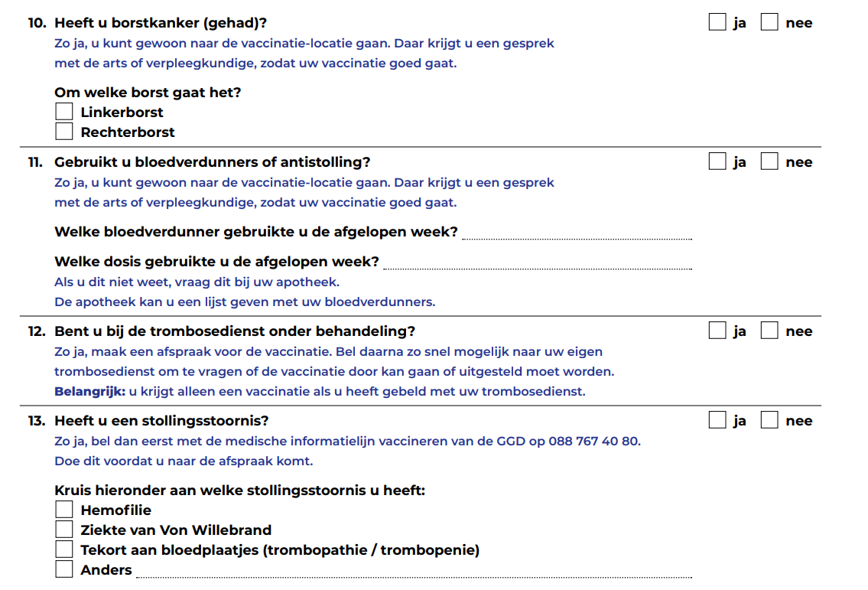

**Researcher:** What would you recommend Manuel to do next?

**Participant:** The same. Ask to talk to a doctor. Yes, just to understand. Of course, if that is not possible I would go run a translation.

**Researcher:** Have you ever found yourself in a similar situation?

**Participant:** Uhm it happened to me when I had to do-do tax declaration. And there instead of facing the tax declaration I decide to go for consultancy.

**[STAGE 6 SLIDE 9]**

**Researcher:** “Manuel asks for help from the young man behind the counter. He asks in Dutch if he can explain what is “bloedverdunners of antistolling”,  “trombosedienst onder behandeling”, and “stollingsstoornis” by pointing at the form with his finger. The young man looks surprised. He looks at the next counter, and it is empty. He looks behind, and everyone seems busy. He then tries to start a sentence a couple of times and finally says in English that these are diseases.”What would you recommend Manuel to do next?

**Participant:** Uhm, he doesn’t know if he has the diseases. Some hyphotesis, for example, trombosis we call in Italy trombosi, sometimes you can go for uhm, but that is dangerous, because, uh, you can have also false friends Uh: So yeah, I-I will go with translation. I will-I will use a vocabulary uh, on performing translating the-the specific one, because I-or-or, yeah I would do that.

**Researcher:** Have you ever found yourself in a similar situation?

**Participant:** Not about diseases and stuff like that, but about some words, when I-I-I understand the focus of answer is directed to very specific one, I go deeply on the word, but I use the vocabulary. For me, I can also go to Wikipedia or whatever. Uhm, if a, uhm, I know the answer, that the moment that I discover trombosis is, I’m fine, I know the answer. Then, I focus.

**[STAGE 7 SLIDE 10]**

**Researcher:** “Manuel turns to his phone, opens the Google Translate app, and types the words he does not understand.”In your opinion, is Manuel taking a risk by using Google Translate?

**Participant:** Uh, yeah he is, because the translation is without responsibility. So when he will answer, of course he will answer at the best of his knowledge, but maybe he is answering to something that he is not understanding. So, uhm, he is taking risks, answering to something he does not understand.

**[STAGE 8 SLIDE 11-15]**

**Researcher: “**Manuel turns to his phone, opens the Google Translate app, and types the words he does not understand.”

We are going to use a scale for the following questions:

5 = to a very high degree

4 = to a high degree

3 = to a moderate degree

2 = to a low degree

1 = not at all

Is the scale clear?

**Participant:** Ok.

**Researcher:** What level of understanding do you think Manuel has when using the app? Does Manuel understand the text…

5 = to a very high degree

4 = to a high degree

3 = to a moderate degree

2 = to a low degree

1 = not at all

**Participant:** Uhm, I will say three.

**Researcher:** What degree of risk of significant harm is Manuel exposed to if using the app? Is Manuel’s health at risk?

5 = to a very high degree

4 = to a high degree

3 = to a moderate degree

2 = to a low degree

1 = not at all

**Participant:** Uh, I would say to a low degree, so two.

**Researcher:** What degree of trust should Manuel have in these translations? Should Manuel trust these translations?

5 = to a very high degree

4 = to a high degree

3 = to a moderate degree

2 = to a low degree

1 = not at all

**Participant:** Uhm, I would say three.

**Researcher:** What degree of vulnerability do you think Manuel has while using the app? Is Manuel at risk of being vulnerable?

5 = to a very high degree

4 = to a high degree

3 = to a moderate degree

2 = to a low degree

1 = not at all

**Participant:** Uhm, I would say three.

**Researcher:** Are there any other comments about this scenario or related scenarios you can think of?

**Participant:** Uhm, no.

**[Training - follow-up questions – SLIDES 16-17]**

**Researcher:** Before we end the interview, we also wanted to ask you what sort of training on using these machine translation apps you would find helpful.

What type of information on machine translation would make your life easier when using these apps in health contexts?

For instance, do you feel you need more instructions on how to use the apps? Can you give us an example?

What about information about how to deal with the translations themselves? Do you have an example?

Would it be helpful to understand better the instances when machine translation is not advisable?

**Participant:** Uhm, now, I’m more of an advanced user, I would not need this type of training. But, uhm, in general, I would say, uhm, DIY, how to use DIY and understanding of the quality of the translation that you will see. Because sometimes, uhm, if you translate just one word, you completely go out of the trail without even noticing. I think that, uh, depending on the top of the person, uh, most of the solution can be done, but the highest quality you can uhm get in person, uhm creating life situations that are uhn, are common, that the person can relate.

**Researcher:** How would you like access to more information to make using these apps easier?

For instance, would you prefer to have short videos on a website or YouTube, step-by-step guides, or infographics?

Would you prefer to be offered free in-person training? And where?

If there was a website with infographics and videos explaining how to use these apps better, would you find that helpful?

**Participant:** Of course you can do in a uhm video way, it would be less expensive in both ways, because person can be also very busy. So I would go also for the video option, for, uhm, for people who cannot be there, but also in a uhm, place, uhm, present, in present course, I think-I think would be good.

**[Closing]**

**Researcher:** Thank you for participating in our research. Our times of analysis and publication are long, but feel free to write to us to obtain the results of this research. Otherwise, we will contact you with the results in due time.